**Name: Atharva shevate**

**RollNo: 02**

**Div: E1**

**SRN: 202201727**

**AS LAB Assignment 8**

**Assessing Network Security Through Penetration Testing**

1. **Problem Statement:**

In today's interconnected digital landscape, ensuring the robustness of network security is paramount for safeguarding sensitive information and maintaining operational integrity. Penetration testing, a proactive security assessment technique, serves as a crucial tool for identifying vulnerabilities and assessing the resilience of network defenses. This experiment aims to evaluate the effectiveness of penetration testing in uncovering security weaknesses and enhancing overall network security posture.

1. **Introduction:**

In today's digital era, where interconnectedness is the norm, safeguarding sensitive information and maintaining operational integrity have become paramount concerns for organizations of all sizes. As businesses rely increasingly on digital infrastructure to conduct operations and store critical data, the need to protect against cyber threats has never been more pressing. Among the myriad tools and techniques available to bolster network security, penetration testing stands out as a proactive approach to identifying vulnerabilities and assessing the resilience of defense mechanisms.

1. **Why Network Security is Necessary to Protect:**

Network security is essential for safeguarding sensitive data, ensuring business continuity, and protecting the integrity of operations. Without robust network security measures in place, organizations are vulnerable to a wide range of cyber threats, including data breaches, malware infections, ransomware attacks, and unauthorized access to confidential information. The consequences of a successful cyber attack can be severe, resulting in financial losses, reputational damage, legal liabilities, and disruption of business operations. Therefore, investing in network security is critical for mitigating these risks and maintaining the trust of customers, partners, and stakeholders.

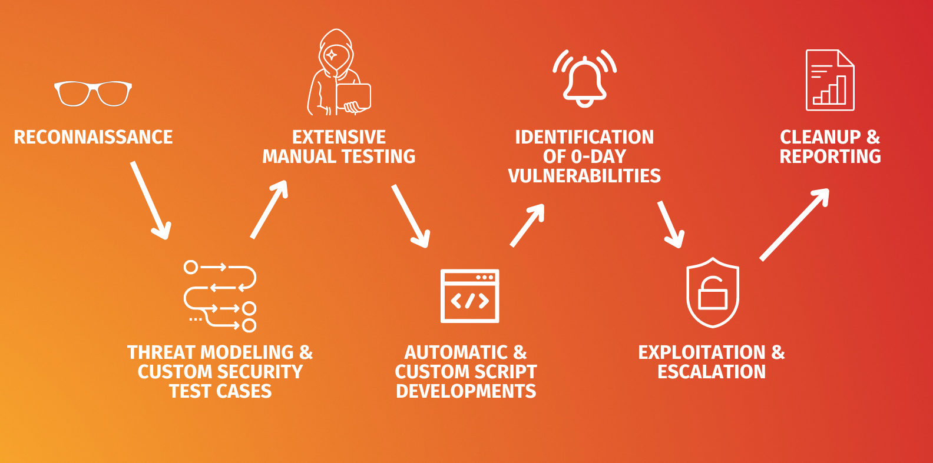

1. **Types of Attacks:**
2. **Malware Attacks:**

Malicious software (malware) such as viruses, worms, Trojans, and ransomware can infiltrate systems and networks, causing data loss, system downtime, and financial damage.

1. **Phishing and Social Engineering:**

Attackers use deceptive techniques such as phishing emails, social engineering tactics, and pretexting to trick users into divulging sensitive information or performing actions that compromise security.

1. **Denial-of-Service (DoS) Attacks:**

These attacks aim to disrupt the availability of services by flooding targeted systems or networks with excessive traffic, rendering them inaccessible to legitimate users.

1. **SQL Injection and Cross-Site Scripting (XSS):**

These web-based attacks exploit vulnerabilities in applications to execute malicious code, steal data, or gain unauthorized access to servers and databases.

Insider Threats: Malicious or negligent actions by insiders, such as employees, contractors, or business partners, can pose significant risks to network security by intentionally or unintentionally disclosing sensitive information or sabotaging systems.

1. **Securing Against Attacks:**

To enhance network security and mitigate the risks of cyber attacks, organizations can implement a comprehensive set of security measures, including:

Firewalls and Intrusion Detection/Prevention Systems: Deploying firewalls and intrusion detection/prevention systems helps monitor and control network traffic, blocking unauthorized access and detecting suspicious activities.

Regular Software Updates and Patch Management: Keeping systems, applications, and firmware up to date with the latest security patches helps address known vulnerabilities and reduce the risk of exploitation by attackers.

Strong Authentication and Access Controls: Implementing multi-factor authentication, strong password policies, and role-based access controls limits unauthorized access to sensitive data and resources.

Employee Training and Awareness Programs: Educating employees about common cyber threats, phishing scams, and best practices for maintaining security helps mitigate the risks of human error and insider threats.

Encryption: Encrypting data both at rest and in transit protects sensitive information from unauthorized access, ensuring confidentiality and integrity.

Regular Penetration Testing and Security Assessments: Conducting regular penetration tests and security assessments helps identify and remediate vulnerabilities before they can be exploited by attackers, thereby enhancing overall network security posture.

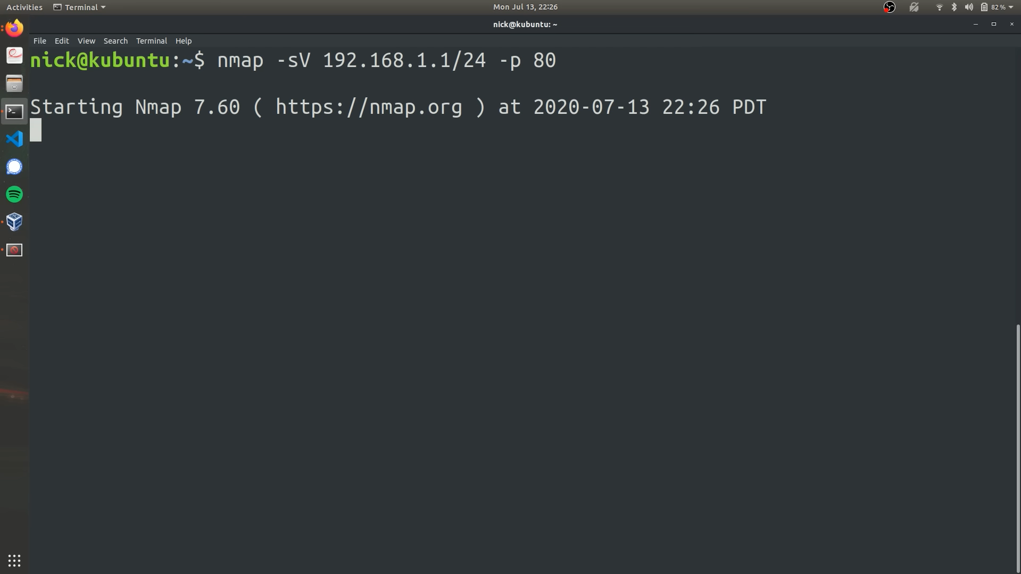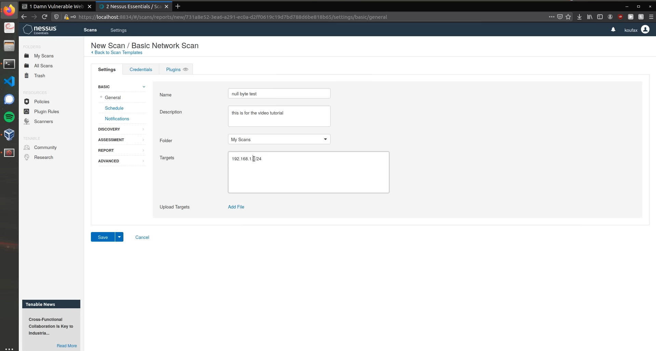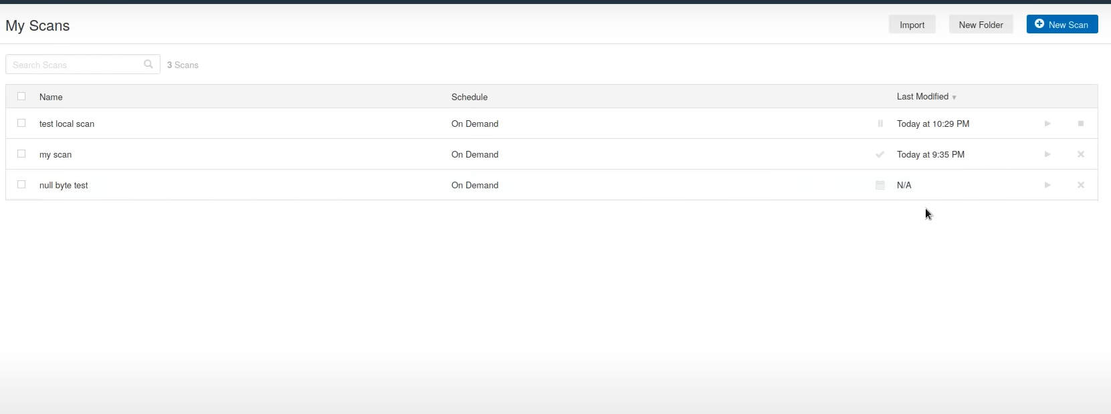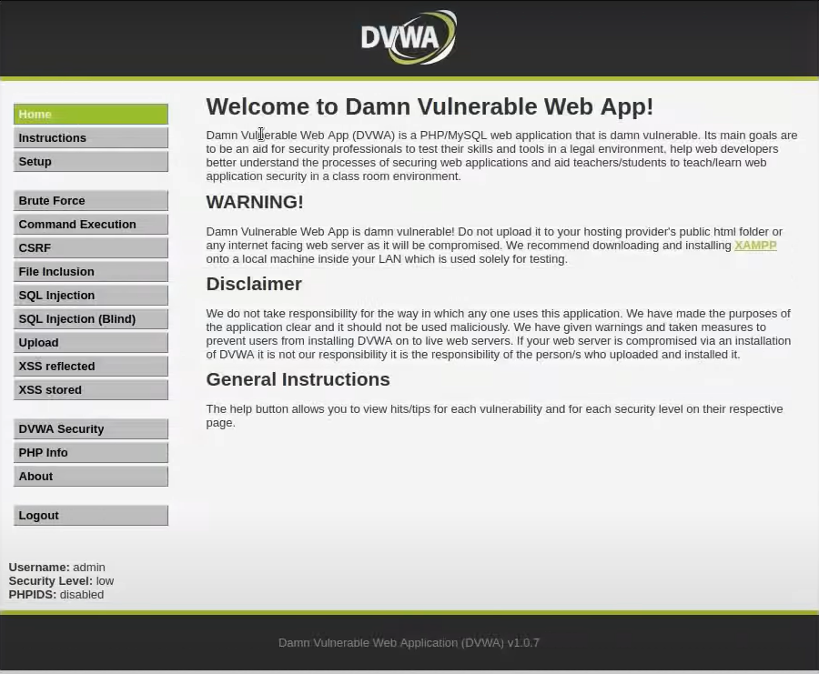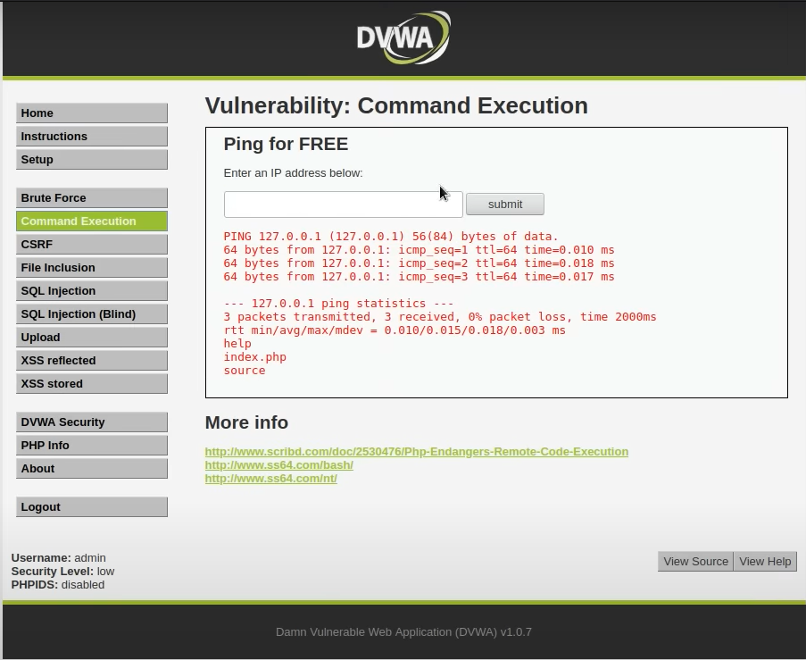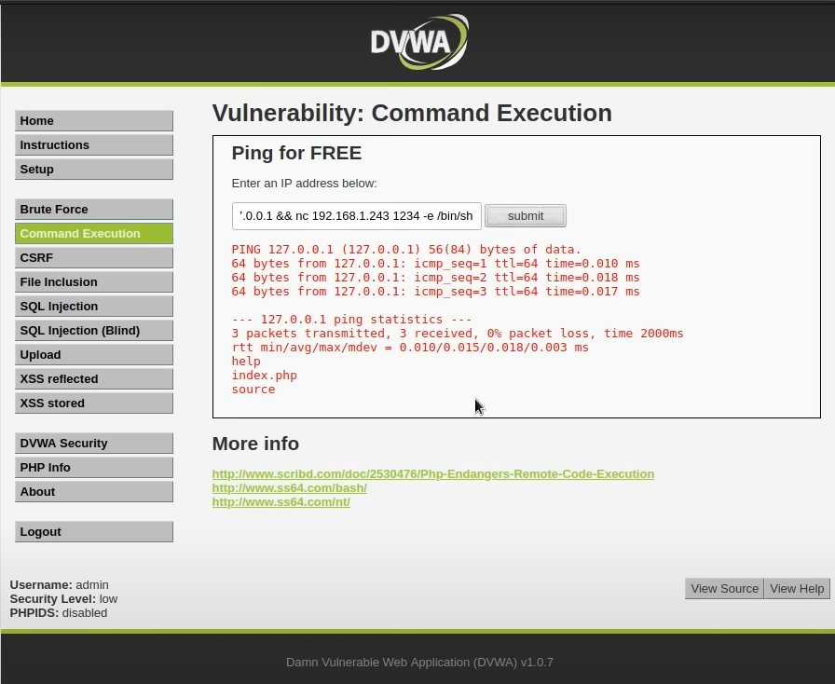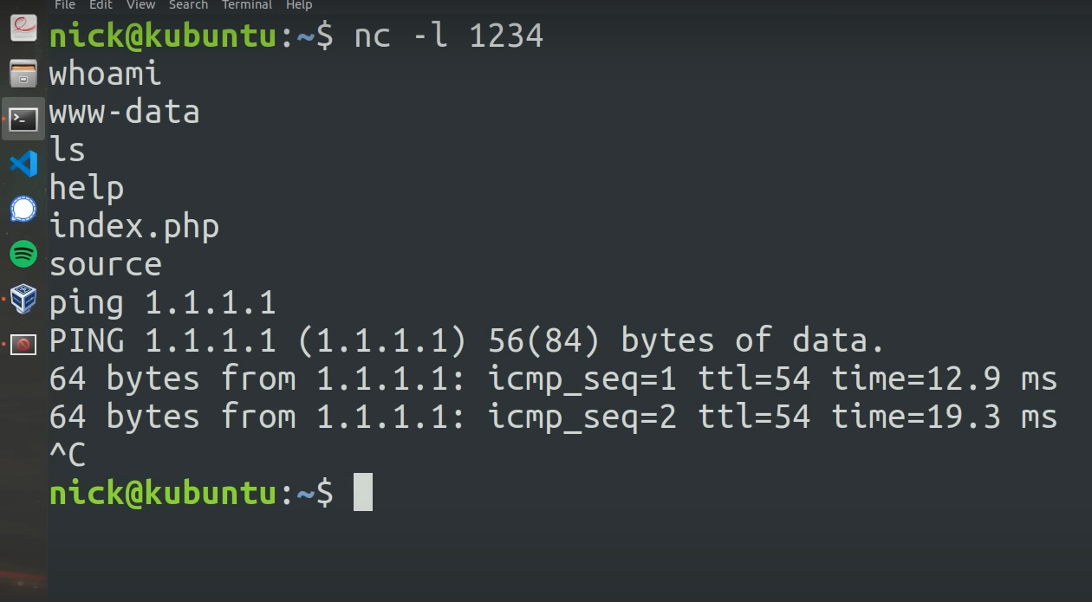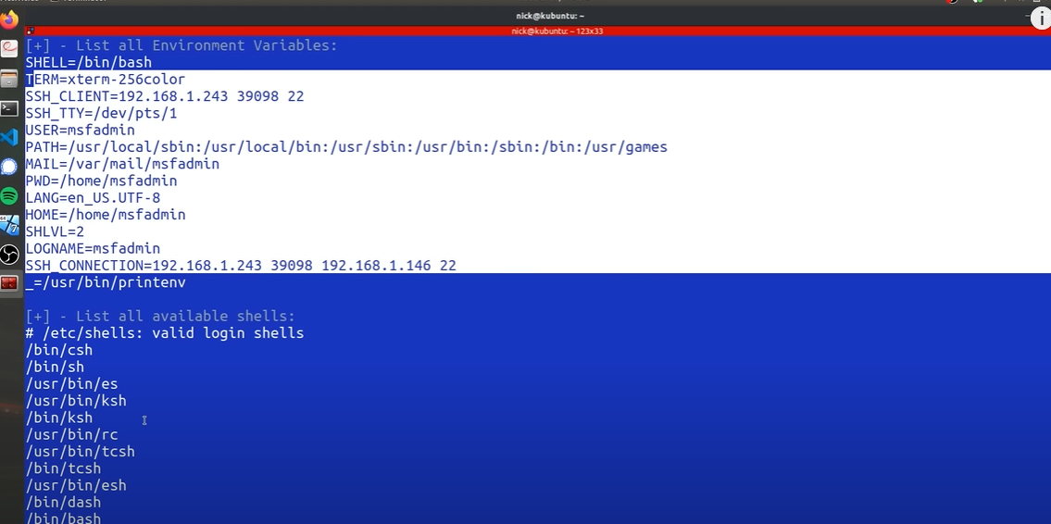

**Conclusion:**

In conclusion, maintaining robust network security is essential for protecting sensitive information, safeguarding business operations, and mitigating the risks of cyber attacks. Penetration testing serves as a proactive measure to evaluate the effectiveness of existing security controls, identify potential vulnerabilities, and strengthen defense mechanisms. By adopting a multi-layered approach to security, including technology solutions, employee training, and regular assessments, organizations can enhance their resilience against evolving cyber threats and maintain trust and confidence in their digital infrastructure.